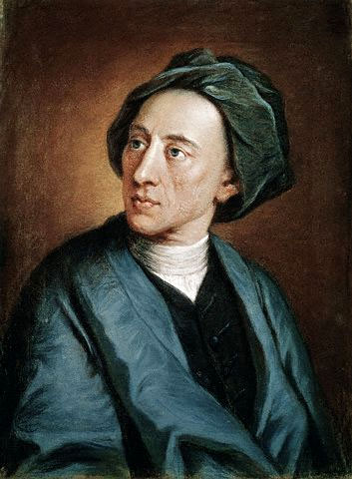Alexander Pope

Like Swift and Dryden, Pope stands as one of the most important writers of the era, and so we will examine two of his most famous works, The Rape of the Lock, and The Dunciad. Pope’s mastery of poetic language and form is witty and musical. Watch for specific techniques like: parallelism, balance, antithesis, elision, syntactical inversion, personiﬁcations, and abstractions.
In The Rape of the Lock, Pope tells a classic story in a delightful way. Although the psychological dimensions of Augustan poetry are often underplayed in favor of ﬁgures of logic and intellectual or moral themes, Pope lavishes attention on his characters and their world(s) in this poem and creates a compelling psychological drama that engages readers. Pope’s richly visual and charmingly musical poem illustrates how the language of poetry constructs a psychological environment for the narrative. An initial focus on the beauty, emotions, and eros that emerge from the details and sounds of the poem will allow for a more meaningful discussion of Pope’s satire and mock-epic form. Once readers are brought into Belinda’s bedroom or the elegant rooms of Hampton court, the more they question what is trivial and what is grand. In the end, it is not at all certain that Pope himself was not ensnared by the beauty of the lock he created.

Discussion Questions:
This week, we will really practice close reading. I have selected various quotes from the text for you to analyze deeply. Look for diction, syntax, rhyme, symbolism, imagery, etc. and examine how the quote contains themes and motifs that are reflective of the whole work. Dig deep!

1. The Tortoise here and Elephant unite,
Transformed to combs, the speckled, and the white.
Here files of pins extend their shining rows,
Puffs, Powders, Patches, Bibles, Billet-doux.
Now awful Beauty puts on all its arms;
The fair each moment rises in her charms,
(Canto 1 135-140)
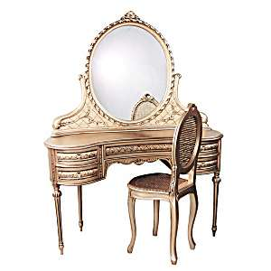
2. On her white breast a sparkling Cross she wore,
Which Jews might kiss, and Infidels adore.
(Canto 2 7-8)
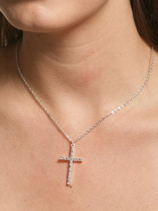

3. For this, ere Phoebus rose, he had implor'd
Propitious heav'n, and ev'ry pow'r ador'd,
But chiefly Love--to Love an Altar built,
Of twelve vast French Romances, neatly gilt.
There lay three garters, half a pair of gloves;
And all the trophies of his former loves;
(Canto 2 35-40)


4. To fifty chosen Sylphs, of special note,
We trust th' important charge, the Petticoat:
Oft have we known that seven-fold fence to fail,
Tho' stiff with hoops, and arm'd with ribs of whale;
Form a strong line about the silver bound,
And guard the wide circumference around.
(Canto 2 117-122)
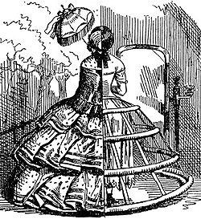

5. The Knave of Diamonds tries his wily arts,
And wins (oh shameful chance!) the Queen of Hearts.
At this, the blood the virgin's cheek forsook,
A livid paleness spreads o'er all her look;
She sees, and trembles at th' approaching ill,
Just in the jaws of ruin, and Codille.
(Canto 3 87-92)
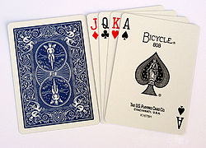

6. Steel could the works of mortal pride confound,
And hew triumphal arches to the ground.
What wonder then, fair nymph! thy hairs should feel,
The conqu'ring force of unresisted steel?
(Canto 3 175-178)


7. The sister-lock now sits uncouth, alone,
And in its fellow's fate foresees its own;
Uncurl'd it hangs, the fatal shears demands,
And tempts once more thy sacrilegious hands.
Oh hadst thou, cruel! been content to seize
Hairs less in sight, or any hairs but these!"
(Canto 4 171-176)


8. Now meet thy fate, incens'd Belinda cry'd,
And drew a deadly bodkin from her side.
(The same, his ancient personage to deck,
Her great great grandsire wore about his neck,
In three seal-rings; which after, melted down,
Form'd a vast buckle for his widow's gown:
Her infant grandame's whistle next it grew,
The bells she jingled, and the whistle blew;
Then in a bodkin grac'd her mother's hairs,
Which long she wore, and now Belinda wears.)
(Canto 5 87-96)
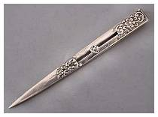

9. When those fair suns shall set, as set they must,
And all those tresses shall be laid in dust,
This Lock, the Muse shall consecrate to fame,
And 'midst the stars inscribe Belinda's name.


