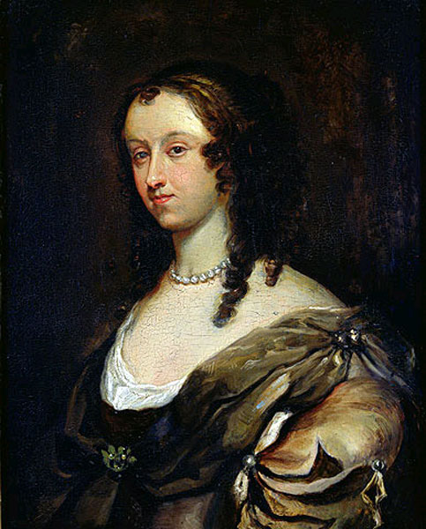 Aphra Behn
Oroonoko, or, The Royal Slave

Oroonoko precedes the genre we think of as the novel and so includes characteristics of many literary types that no longer exist, but which contributed to the novel's characteristics. These include romance, travel narrative, and what became captivity narratives and slave narratives.
Definitions
Romance--Emerged from epic and includes some epic conventions. Romance includes lofty/elevated language, extravagant characters, remote and exotic places, exciting and heroic events, passionate love, mysterious or supernatural experiences. Does not have to be realistic. Sometimes has to do with the activities of a noble family, especially marriages and courtship. Elaborate manners are also important.
Travel Narrative--A popular genre that consisted of an account written by a traveler to distant places. Usually includes a statement that this is an eyewitness account. Focuses on details of the place visited, including the plants and animals found there, the native peoples, their customs, and their manners.
Slave Narrative--A popular genre often associated with the 19th century abolitionist movement in the U.S. Many precursors exist in 18th century British literature. Slave narratives tend to be 1st person accounts written by slaves and detailing the history of their capture, enslavement, efforts to gain freedom, and their productive lives after gaining freedom. Sometimes include elements of spiritual autobiography.
Noble Savage--The idea that primitive human beings are naturally good and that whatever evil they develop is the product of the corrupting action of civilization. Such people are often compared to Adam and Eve in the Garden of Eden before the Fall. This termed is often associated with Jean Jacque Rousseau, the 18th century French philosopher, but its actual origins are from John Dryden’s play, The Conquest of Granada (1672).

Discussion Questions
- Explore how the story is affected by the lens of the Narrator. Is she reliable? Is she limited in her perspective? Does it matter if we verify that the narrator is actually Aphra Behn or if the story is true?
- Examine all of the Paradise Lost images and references. What is the purpose of this theme? (See “noble savage” above)
- Analyze all the references to “eyes” and “hearts.” What symbolism might they convey?
- A foil is a character who contrasts another character (usually the protagonist) in order to highlight particular qualities of the other character. What kinds of foil characters are there to Oroonoko and how do we understand him better in contrast?
- Is this text anti-slavery, anti-monarch, or anti-religion?
- Explore the nature of identity in the text. Who are we? How significant is a name, clothes, or appearance for one’s sense of self?
- Is this a Hero’s Journey in the Joseph Campbell sense? (Ordinary world, Call to adventure, Wise mentor, etc.)
- What is significant about the ending? Is it odd that the novel ends with praise "of the brave, the beautiful and the constant Imoinda"?
- How is this a Neoclassical text?

