Scheduling Honors Classes: Add the Cohort Restriction
When you schedule an Honors section, add the HONO2 cohort restriction so the section is restricted to students in the Honors DA cohort.
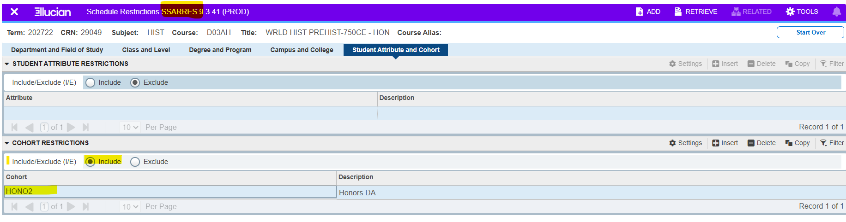
- Open SSARRES (Schedule Restrictions) in Banner.
- Enter the term and the Honors section’s CRN, then open the record.
- Select the Student Attribute and Cohort tab.
- In the Cohort Restrictions section, select Include under Include/Exclude.
- Click Insert and enter HONO2 in the Cohort field. The description should display Honors DA.
- Save the record.
- Reopen or refresh the CRN and confirm that Include is selected and HONO2 – Honors DA appears under Cohort Restrictions.
Before marking the section complete: Check every Honors CRN individually. The restriction must be present on each Honors section, even when it is paired or bundled with another class.

