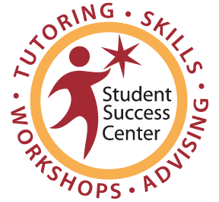
Math, Science & Technology Resource Center

Weekly Individual Tutoring (WIT)
Student Checklist

Tutor Instructions: Please mark the appropriate box(es) with the date(s) when each skill was completed. For status: C=Complete , I=Incomplete , N=No Work
If the skill was completed, remind your student to complete the next skill or to pick a desired topic. If the skill was incomplete, identify why it was not completed and either, help the student complete the skill or the student must bring it completed for the next session. If no work was completed, in addition to the same as incomplete, explain the importance of fulfilling their WIT Participant Agreement, that s/he may be dropped from WIT if this persists, and the impact it will have on their success in all courses.

Skill Status
C I N
Math Skills Pre-Assessment Test
Getting to Know You
MSTRC Orientation
Creating a Commitment & Goal
Note-Taking
Wise Choice Process
Math Anxiety
Study Skills Techniques
Motivation
Instructor Meeting
Test-Taking
Time Management
Reading Math Text
Math Skills Post-Assessment Test

